CS 340 Project Two README
Overview
This project was about building an interactive dashboard using Python, Dash, and MongoDB. The goal was to let users explore animal shelter data in a simple and clear way. The dashboard connects to the database, pulls the data, and allows users to filter and view it through different components.

Tools and Technologies Used
- Python
- Dash using JupyterDash
- Plotly Express
- MongoDB
- Pandas
- Dash Leaflet for the map

Functionality
Interactive Filtering
- Radio buttons allow the user to filter the data
- Options include water rescue, mountain or wilderness rescue, disaster or individual tracking, and reset
- Each selection runs a query and updates the dashboard

Data Table
- Displays animal records from the database
- Allows sorting and filtering
- Includes pagination for easier navigation
- Updates automatically when filters are applied

Data Visualization
- Pie chart shows the most common animal breeds
- Limited to the top ten breeds to keep it readable
- Updates based on the filtered data

Geolocation Map
- Displays the location of the selected animal
- Uses latitude and longitude from the dataset
- Updates when a row is selected in the table
- Includes a tooltip for breed and a popup for the animal’s name

Key Features Implemented
- MongoDB queries connected to user input
- Dash callbacks to update components dynamically
- Data handling with Pandas
- Interactive table and visual elements
- Handling cases where no selection is made
- Removed the id field to prevent table errors

Screenshots
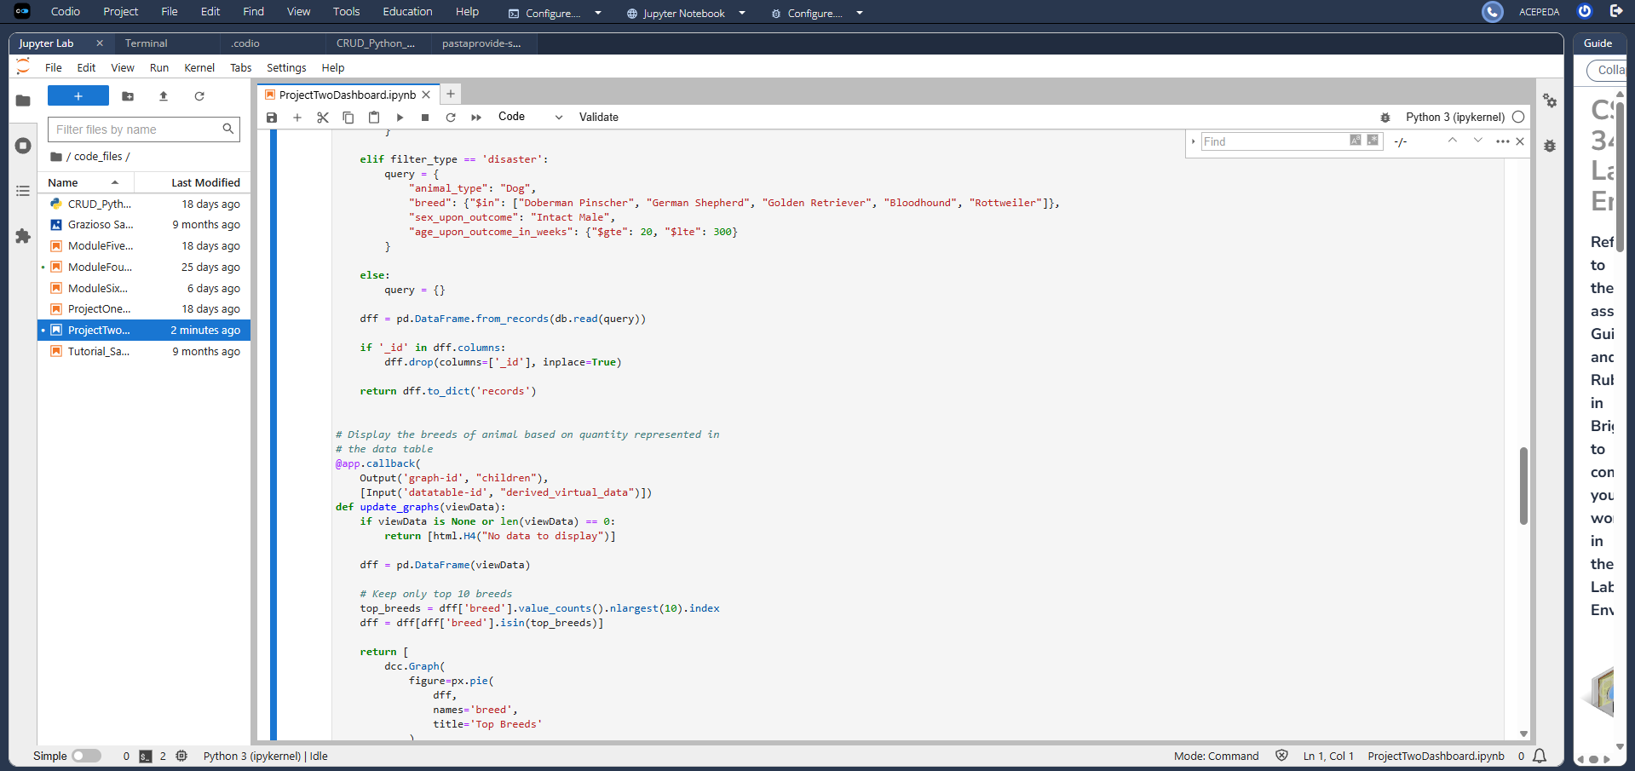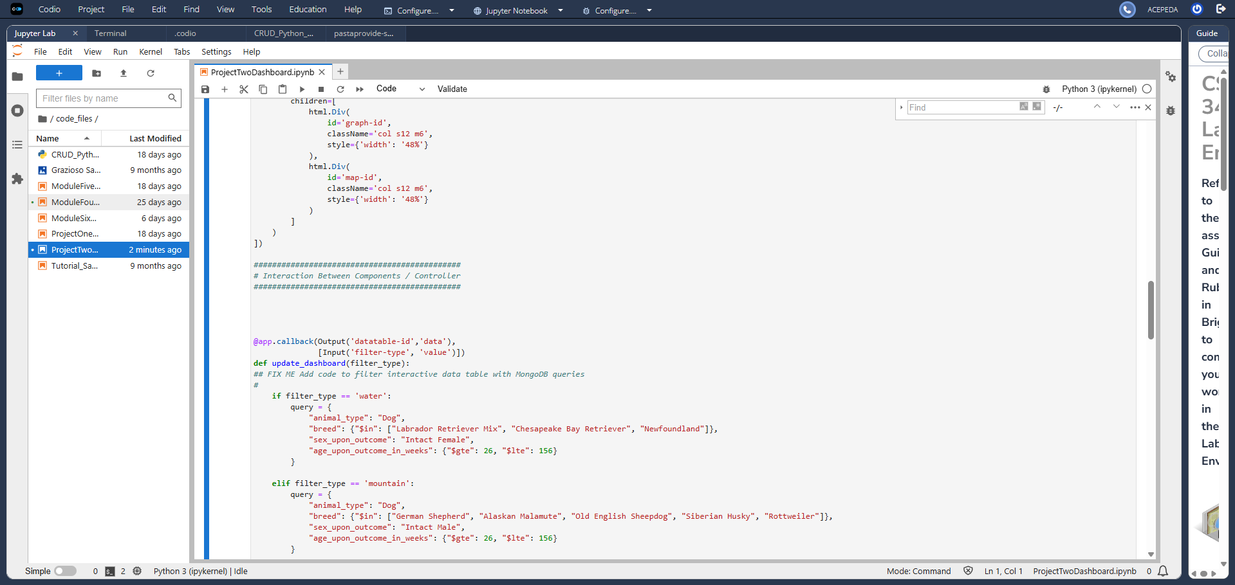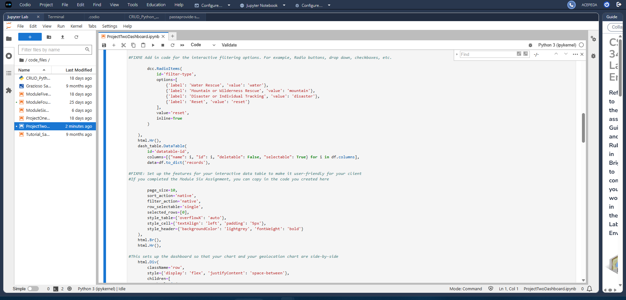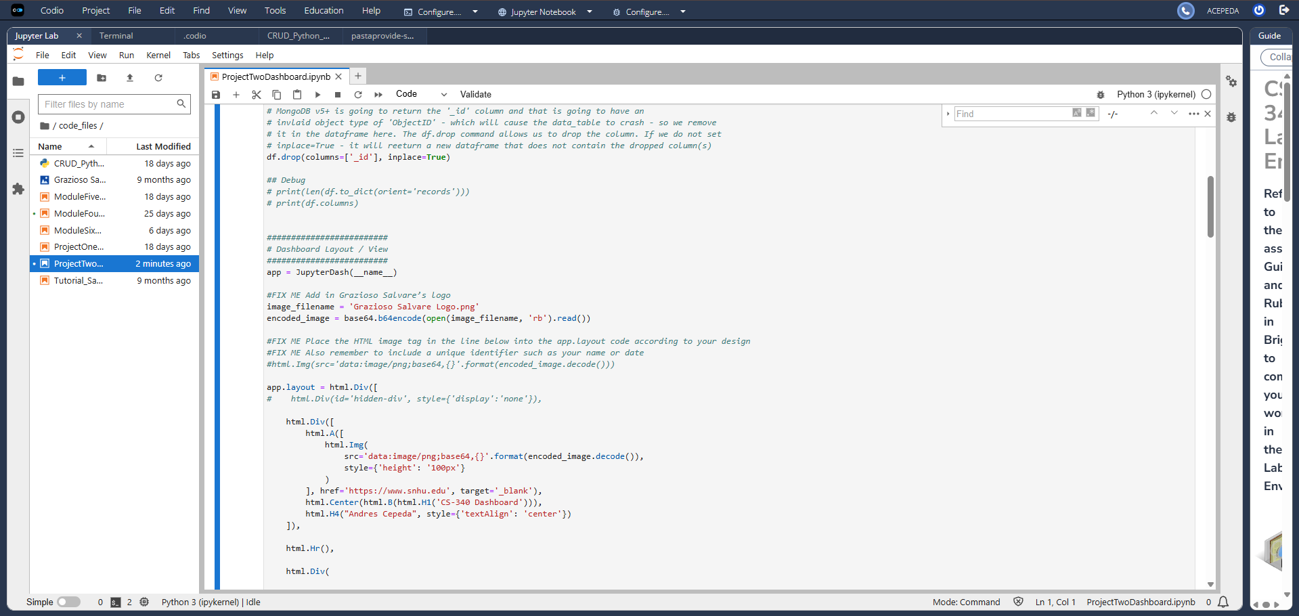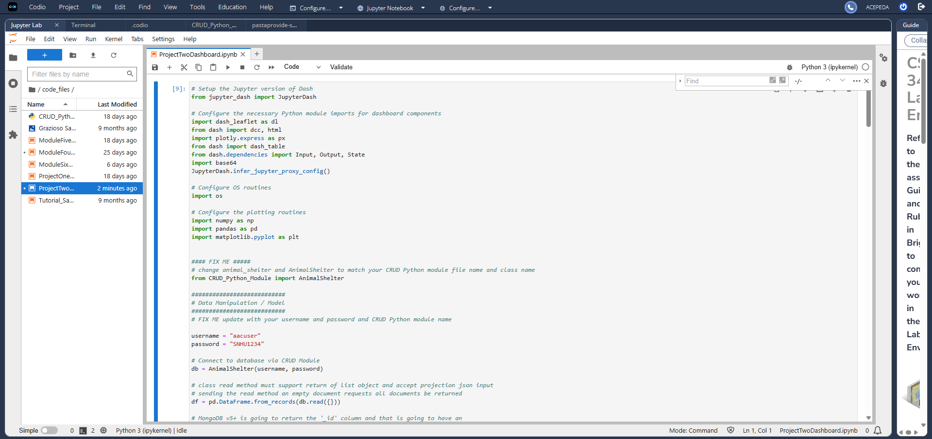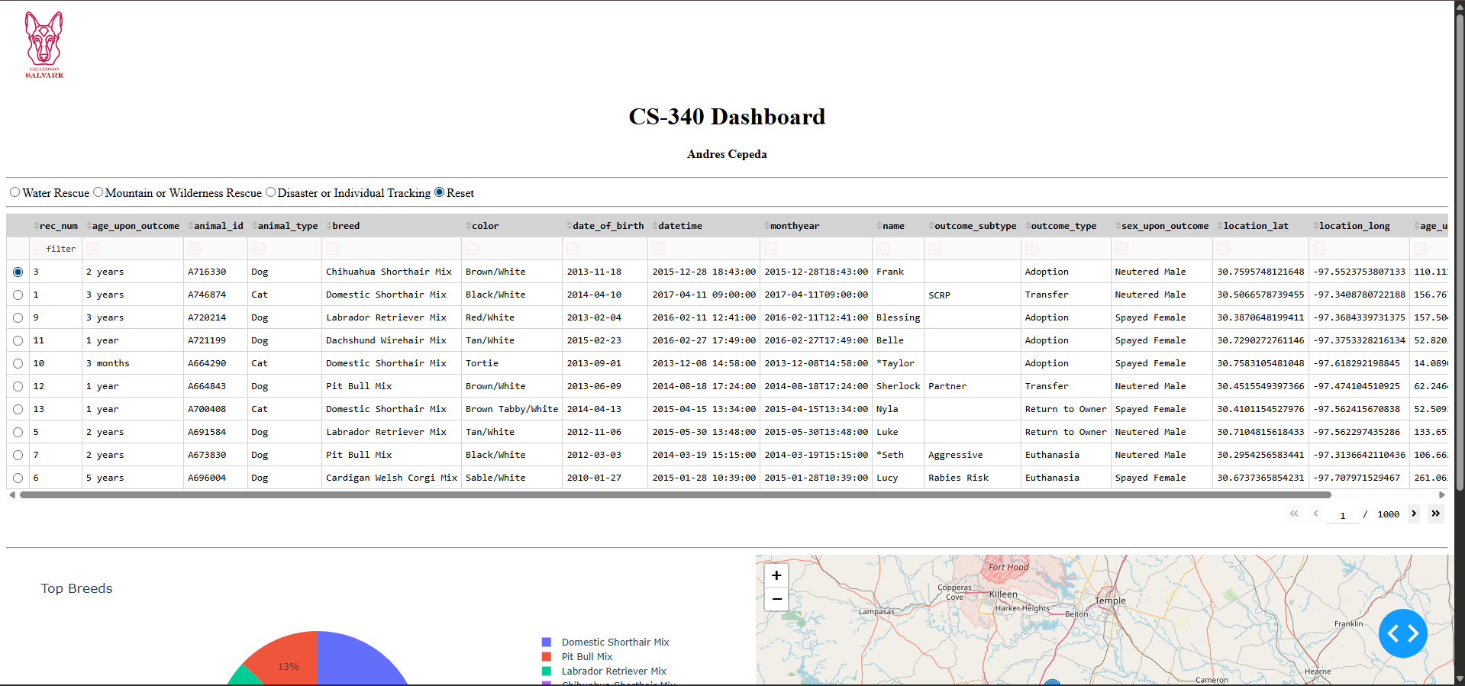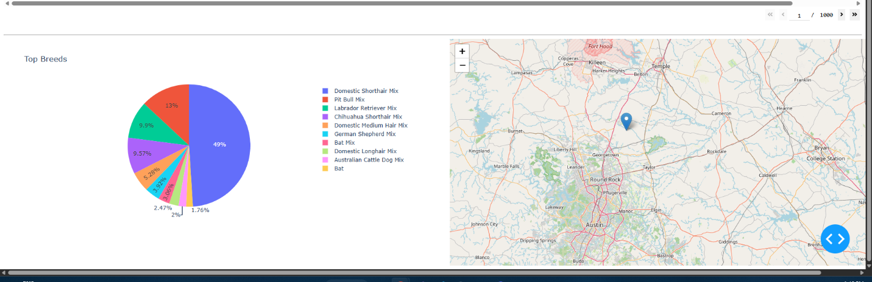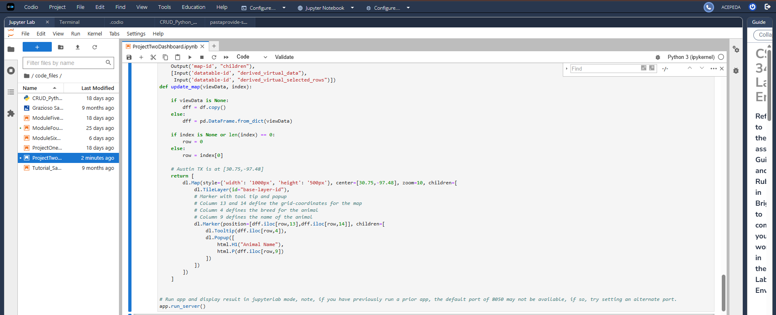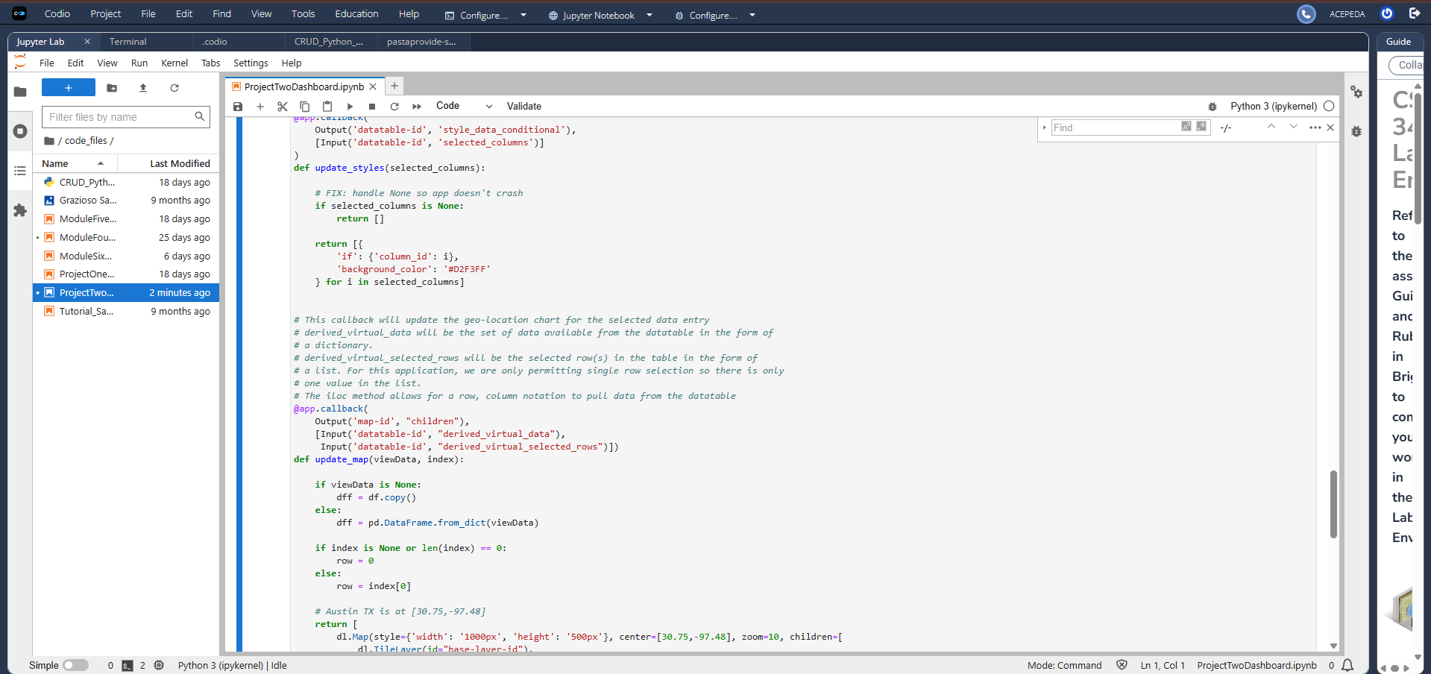
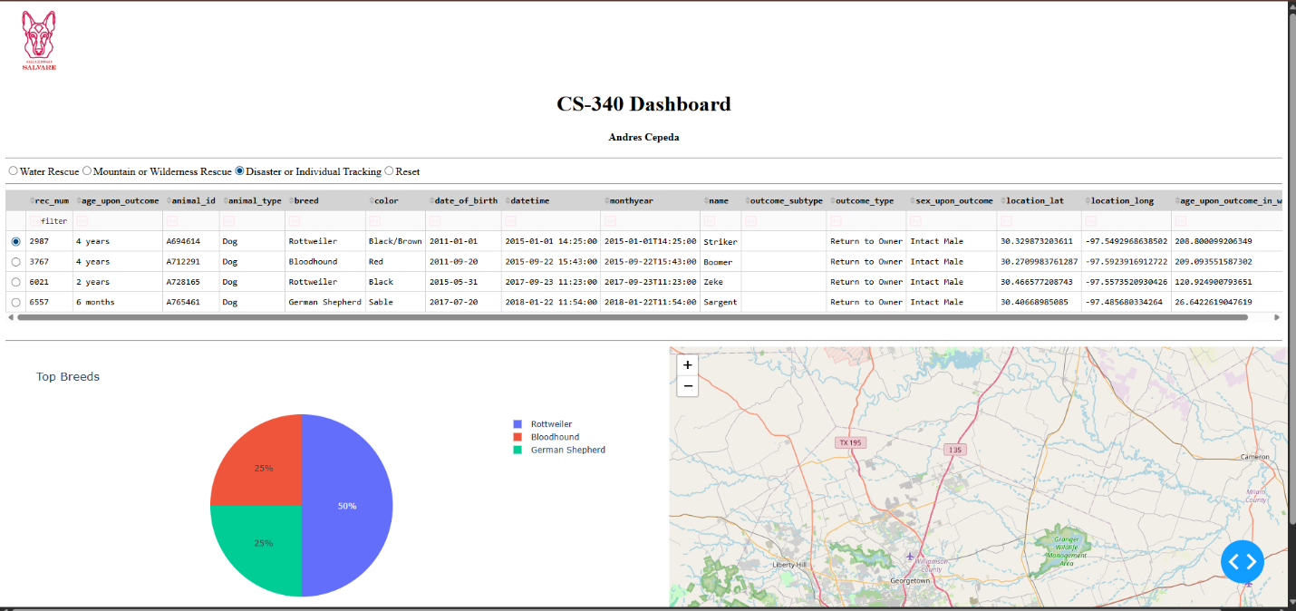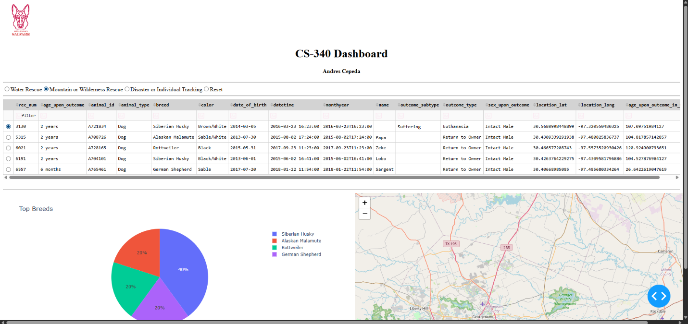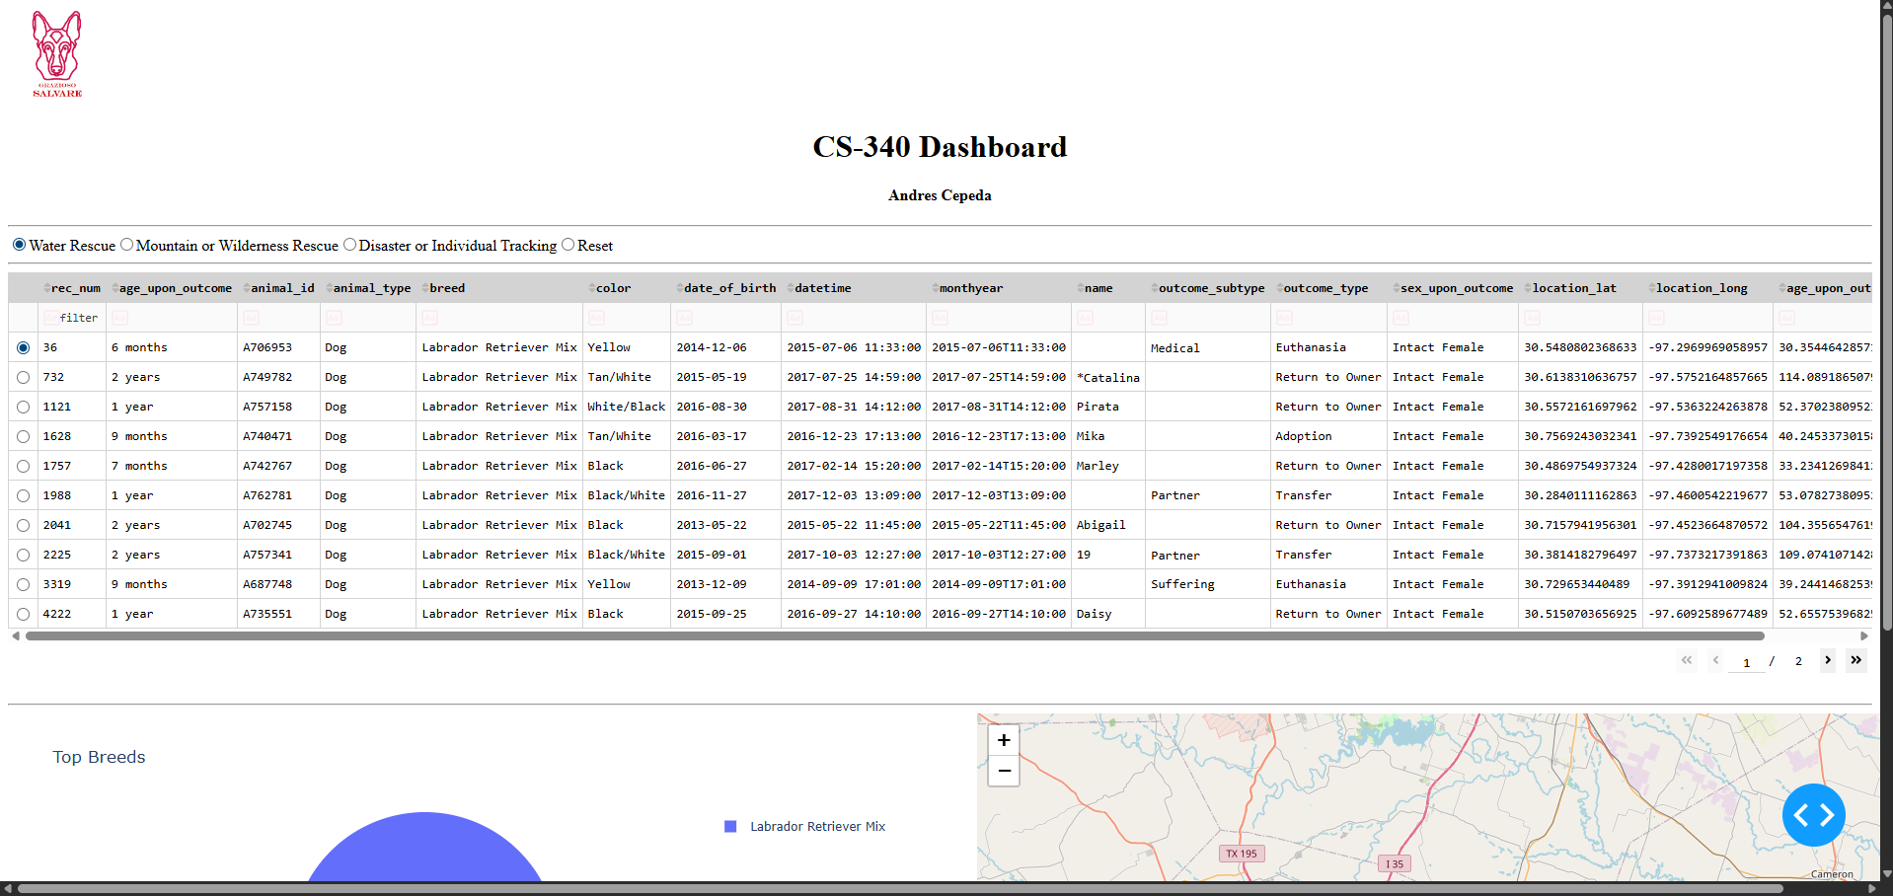
Challenges and Solutions
- The dashboard would crash when no column was selected
  - This was caused by a null value in the callback
  - Fixed by adding a condition to check for None
- The pie chart was difficult to read at first
  - Too many categories were being displayed
  - Fixed by limiting it to the top ten breeds

Conclusion
This project helped me understand how to connect a database to a dashboard and make the data interactive. I was able to build a working application that lets users filter data, view it in a table, and see it displayed visually. It also helped me get more comfortable working with Dash and handling real data.
Reproduction Instructions
To run this project, the following steps were taken:
- Set up MongoDB and import the animal shelter dataset into the aac database
- Create a MongoDB user named aacuser with the appropriate permissions
- Use the CRUD Python module to connect to the database
- Open the ProjectTwoDashboard.ipynb file in Jupyter Notebook or Codio
- Run all cells to start the dashboard
- The dashboard will launch in the browser and allow interaction with filters, table, chart, and map

